No | Code | Name | QT
1. | OTA69405929S | Rug My Home, 60 x 90 cm, blue | 5 | 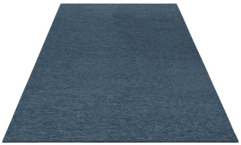
2. | ABE3742 | Rug Danca, multicolor light 160 x 230 cm | 15 | 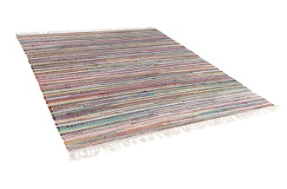
3. | OTA369683L | Rug Imran Home affaire Collection, 160 x 230 cm, taupe | 10 | 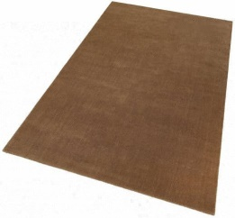
4. | OTA571548 | Rug Home Affaire Indra 160 x 230 cm, red | 5 | 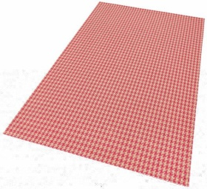
5. | OTA609627L | Rug Agota Andas 120 x 180, brown | 10 | 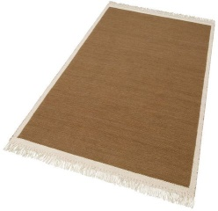
6. | OTA765440 | Rug my home Tino 160 x 230 cm,Blue | 20 | 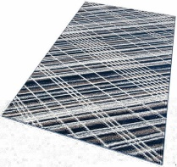
7. | OTA15828409S | Rug Noa Andas 60 x 90, Light Gray | 10 | 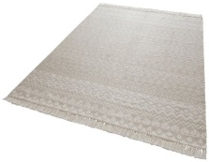
8. | OTA15828409XL | Rugs Noa Andas 160 x 230, Light Gray | 10 | 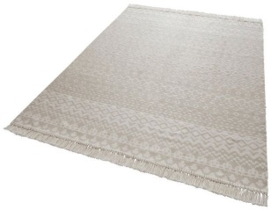
9. | OTA18460132XL | Cross Bruno Banani Akai, 75 x 190 cm | 12 | 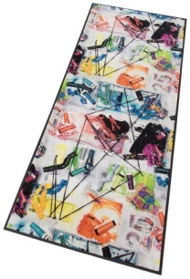
10. | OTA39783902L | Rug Rico de Theko Exclusiv 120 x 180 cm, Beige-Green | 10 | 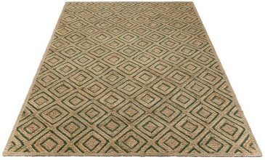
11. | OTA54550843S | Rug Jasmin Home affaire Collection 60 x 90 cm, blue | 27 | 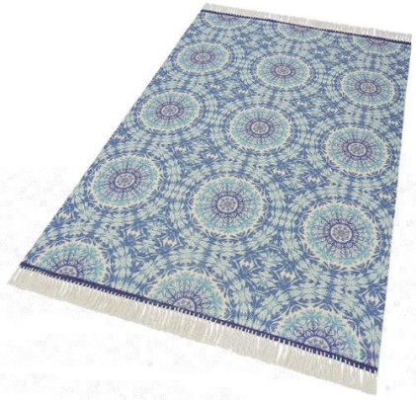
12. | OTA54550843m | Rug Jasmin Home affaire Collection 80 x 150 cm, blue | 44
13. | OTA54550843L | Rug Jasmin Home affaire Collection 120 x 180 cm, blue | 28
14. | OTA54550843XL | Rug Jasmin Home affaire Collection 160 x 230 cm, blue | 19
15. | OTA217103XXL | Rug Bruno Banani Malibu 240 x 320 cm | 10 | 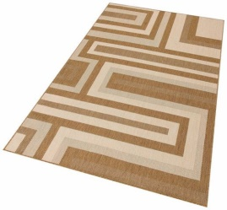
16. | OTA266807XL | Rug Guido Maria Kretschmer Home & Living, 160 x 230 cm, yellow | 8 | 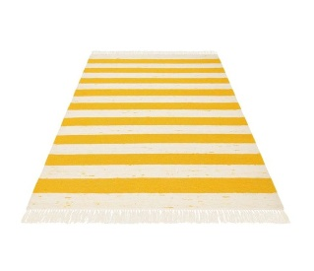
17. | OTA615511XL | Rug Jordi my home, 120 x 180 cm, gray | 8 | 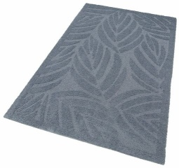
18. | OTA799405S | Rug Guido Maria Kretschmer Home & Living, 60 x 90 cm, turquoise | 20 | 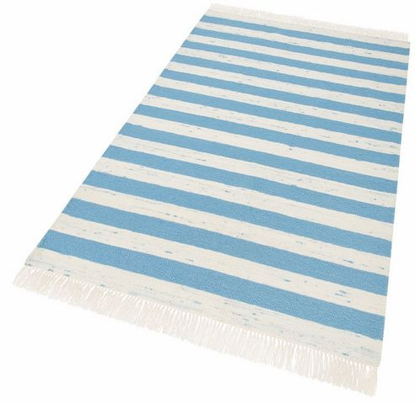
19. | OTA799405M | Rug Guido Maria Kretschmer Home & Living, 80 x 150 cm, turquoise | 20
20. | OTA799405L | Rug Guido Maria Kretschmer Home & Living, 120 x 180 cm, turquoise | 30
21. | OTA799405XL | Rug Guido Maria Kretschmer Home & Living, 160 x 230 cm, turquoise | 15
22. | OTA889349M | Rug Niklas by Home Affaire Collection 80 x 150 cm, natur | 10 | 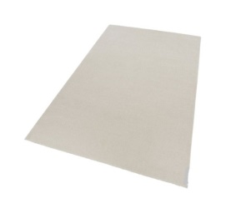
23. | OTA15828409L | Rug Noa Andas 80 x 150, light gray | 30 | 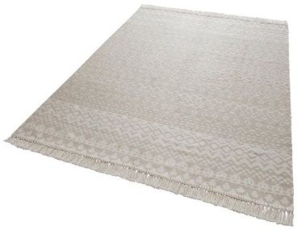
24. | OTA15828409XXL | Rug Noa Andas 120 x 180,light gray | 15
25. | OTA24206149S | Cross Arik by Home Affaire, 60 x 180 cm, gray | 20 | 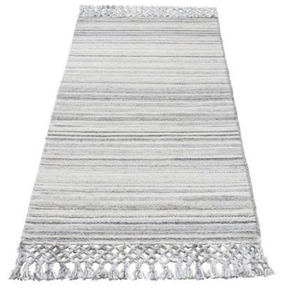
26. | OTA24206149M | Cross Arik by Home Affaire, 70 x 190 cm, gray | 20
27. | OTA24206149ss | Cross Arik by Home Affaire, 75 x 120 cm, gray | 10
28. | OTA47169721M | Rug vinil Amur by My Home 65 x 100, blue | 35 | 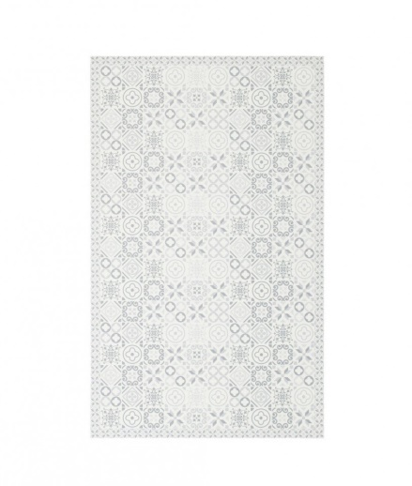
29. | OTA47169721L | Rug vinil Amur by My Home 97 x 140, blue | 20
30. | OTA53372506L | Rug vinil Mandala by My Home 65 x 100, dark red | 43 | 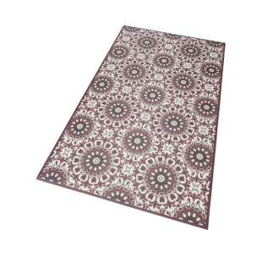
31. | OTA66785857 | Cross vinil Brazo by My Home, 47 x 140 cm, blue-gray | 36 | 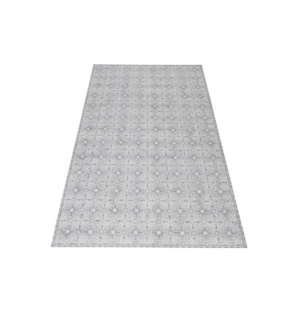
32. | OTA93795559M | Rug Guido Maria Kretschmer 80 x 150 cm, pick-peach | 10 | 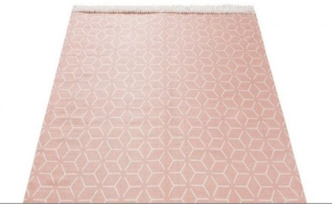
33.. | OTA93795559L | Rug Guido Maria Kretschmer 120 x 180 cm, pick-peach | 10
34. | OTA309238 | Rug Imran Home Affaire Collection, 200 x 300 cm, gray | 10 | 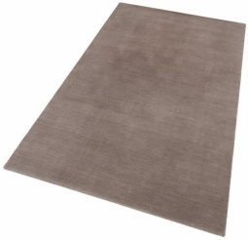
35. | OTA20024050M | Rug Noa Andas 80 x 150, peach | 25 | 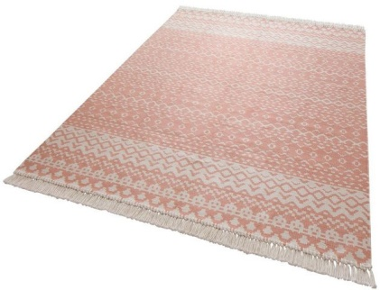
36. | OTA20024050L | Rug r Noa Andas 120 x 180, peach | 10
37. | OTA31008930S | Cross Kakadu by GMK Home & Living 67 x 230 cm, white | 10 | 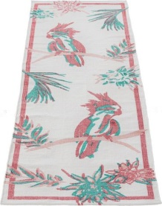
38. | OTA57630245M | Entrance rug Fotbal by my home, 50 x 75 cm, green | 10 | 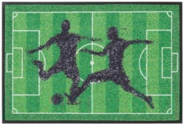
39. | OTA99125800S | Entrance rug Akai by Bruno Banani, 40 x 60 cm, multicolor | 10 | 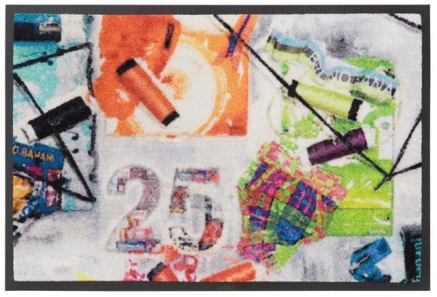
40. | OTA99125800M | Entrance rug Akai by Bruno Banani, 50 x 75 cm, multicolor | 10
41. | OTA99481613S | Cross Rabbit by Bruno Banani, 75 x 120 cm, black | 10 | 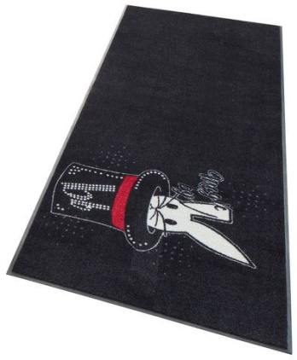
42. | OTA99481613M | Cross Rabbit by Bruno Banani, 75 x 190 cm, black | 20
43. | OTA65196563/1 | Rug Lauri by Home Affaire, blue, 60 x 90 cm | 10 | 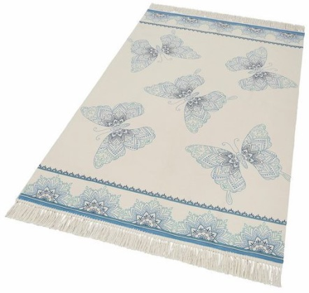
44. | OTA65196563/2 | Rug Lauri by Home Affaire, blue, 80 x 150 cm | 10
45. | OTA65196563/4 | Rug Lauri by Home Affaire, blue, 160 x 230 cm | 10
46. | OTA82068553/1 | Rug Rana by Andas, petrol, 60 x 90 cm | 5 | 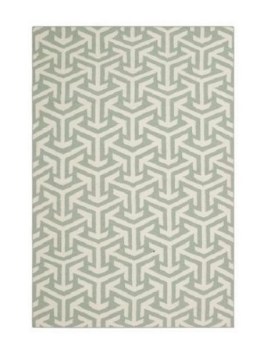
47. | OTA82068553/2 | Rug Rana by Andas, petrol, 80 x 150 cm | 5
48. | OTA82068553/3 | Rug r Rana by Andas, petrol, 120 x 180 cm | 5
49. | OTA85500962/1 | Rug Bogna by My Home pink, 60 x 90 cm | 10 | 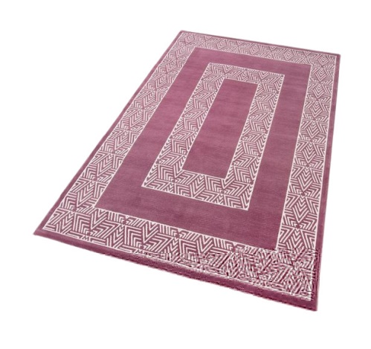
50. | OTA85500962/2 | Rug Bogna by My Home pink, 70 x 140 cm | 10
51. | OTA85500962/3 | Rug Bogna by My Home, pink, 120 x 180 cm | 10
52. | OTA85500962/4 | Rug Bogna by My Home, pink, 160 x 230 cm | 10
53. | OTA97154463/4 | Rug Lauri by Home Affaire, orange 160 x 230 cm | 10 | 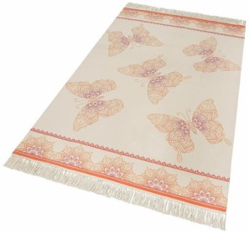
54. | OTA55857402/11 | Cross Amur by My Home 47 x 140, blue | 10 | 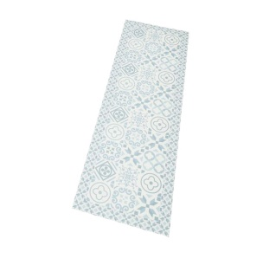
55. | OTA83237130/11 | Cross Mandala, 47 x 140 cm | 10 | 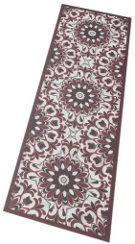
56. | OTA68207706/4 | Rug Murina by My Home, blue 160 x 230 cm | 35 | 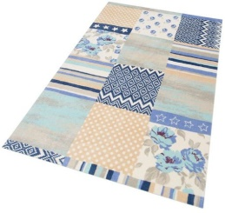
57. | OTA70415967/6 | Rug Firat by Home Affaire, lavanda, 200 x 300 cm | 5 | 